NewsAnimate

# Overview

A web interface will be developed to create videos from news text. <https://www.d-id.com/> serves an   
api to create videos using text input and an image input to create video. Then generated video will be downloaded and played on interface.

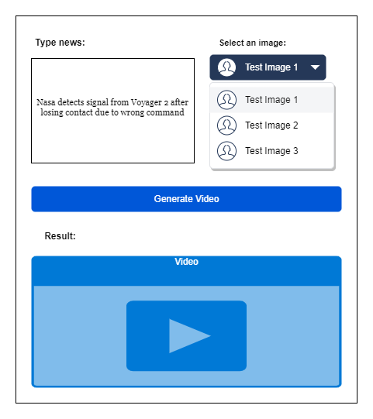

# MILESTONES

1. <https://streamlit.io/> allows creating interfaces coding with pure python. An interface will be created according to the image above.
2. When a news text is typed and an image is selected then generate button is pressed, [www.d-id.com](http://www.d-id.com) api will be called and animated video will be created. Then created video will be downloded and played on interface which is created at step 1.
3. A machine learning model will be created to classify news text. According to the classification result, appropriate image will be selected automatically then video will be created. BBC News Classification dataset can be used to train model.
4. A database will be created using sqlite, postgresql or mongodb to store news text, news category and video.
5. Finally a documentation will be created using existing web interface or using additional solution like mkdocs.